Fig. 2. Risk-of-bias assessment using the Newcastle-Ottawa Scale (NOS).
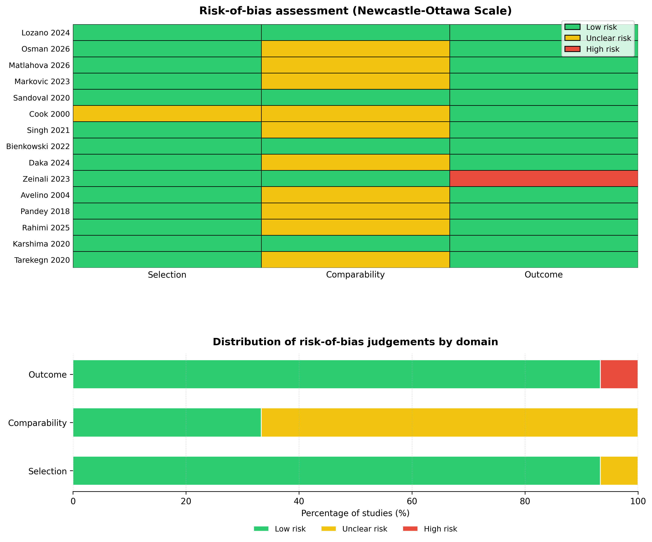
Green indicates low risk of bias, yellow indicates unclear risk of bias and red indicates high risk of bias. The figure summarises judgements across selection, comparability and outcome/exposure domains for the 15 studies included in the quantitative synthesis.

